School of Physical Chemistry 2021
Supramolecular Interactions
in Biological Systems
15th-24th June 2021
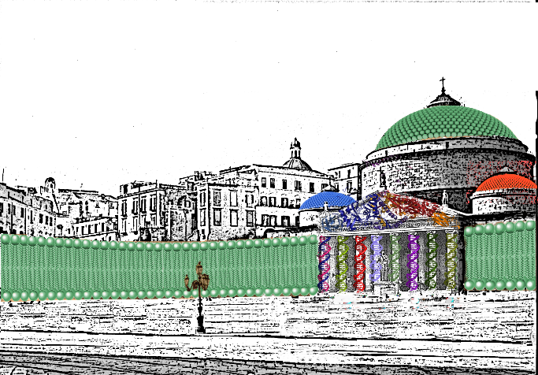

Registration form

Personal Details
First name
Surname
Affiliation
Role
Phone
e-mail
Title of the presentation (the three best presentations will be rewarded)

Payment details
Bank transfer to: Società Chimica Italiana
IBAN: IT57V0306909606100000132456

Processing of personal data
☐ I authorise the treatment of my personal data according to D.Lgs. 196/2003.

